VIDYASAGAR UNIVERSITY

B.Sc. Part –III (3T) Examination, 2019

Computer Science

PROJECT REPORT

ON

Area Based doctor search

Submitted By

Rupa Nayak
Subhankar Maity

CERTIFICATE



This is to certify that Rupa Nayak have submitted the project titled “ Area Based Doctor “ as a partial fulfillment of the bachelor’s degree in Computer Science under Vidyasagar University for the year 2018-2019.
The project was found to be of the requisite standard.

……………………………………… …………………………………….
Signature of Head of the Signature of the Guide
Department Comp Sc. Department Comp Sc.

CERTIFICATE

This is to certify that Subhankar Maity have submitted the project titled “ Area Based Doctor “ as a partial fulfillment of the bachelor’s degree in Computer Science under Vidyasagar University for the year 2018-2019.
The project was found to be of the requisite standard.

……………………………………… …………………………………….
Signature of Head of the Signature of the Guide
Department Comp Sc. Department Comp Sc.

Acknowledgement

I take this opportunity to express my profound gratitude and indebtedness to my guide Mr. Sk. MD. Habibullah for his expertise, optimism, never ending enthusiasm and guidance provided by him from time to time.

I express my sincere thanks to the all staffs of the Department for their kind cooperation.

Last but not least, I would like to thank to the principal of our college, and my friends who directly or indirectly encourage me to make this project work.

Date: Signature

Index

- Project Goal.
- System Development Life Cycle.
- Minimum Hardware/Software Requirement.
- Database.
- E-R Diagram.
- System Diagram.
- Coding.
- Output.
- Testing.
- Conclusion.

Project Goal

Since earlier days we always had to face the problem of finding a doctor for specific disease or an experienced doctor where we can treat ourself.In a large area it is difficult to select those doctors who are actually done better treatment. It is also difficult to know the nearby doctor. People just fixed a doctor without knowing his specifications, his degrees etc. Also they have to remember chamber date, time and location and has to fixed appointment by revisiting the chamber.
To remove this difficulities we have prepared one website which provide an efficient way for finding area based doctors and all information about doctors such as his speciation and experience etc.
By using this website, after registration we can see the area based doctors, can choose the doctors by specifying the body part on which we have problems and we can also fixed an appointment for a selected doctor.

System Development Life Cycle

The traditional methodology used to develop, maintain and replace information systems. This project is developed with this strategy.

  - Project Identification and Selection :

To develop a preliminary understanding of the business situation that has caused the request for a new or an enhanced information system.

  - Project Initiation and Planning :

To state business situation and how information systems might help solve a problem or make an opportunity possible. A written request to study the possible changes to an existing system or the development of a new system.

  - Analysis :

To analyze the business situation thoroughly to determine requirements, to structure those requirements and to select among competing system features.

  - Logical Design :

To bring out and structure all information requirements.

  - Physical Design :

To develop all technology and organizational specifications.

  - Implementation :

To write programs, build data files, test and install the new system and finalize documents.

  - Maintenance :

To monitor the operation and usefulness of a system, and to repair and enhace the system.

Minimum Software/Hardware Requirements

Hardware:

Core i3 or higher processor
      - 2.00 GHz
      - 4 GB RAM
      - Color Monitor

Software:
      - Windows Operating System ( Win 7 OR UPPER)
      - MS SQL SERVER 2008
      - VB .NET 2010

VB.NET
Visual Basic .NET, the next generation of the Visual Basic language, is a fast and easy way to create .NET-based applications, including XML Web services and Web applications.
Visual Basic .NET has many new and improved features that make it a powerful object-oriented programming language, including inheritance, interfaces, and overloading. Other new language features include free threading and structured exception handling. Visual Basic .NET also fully integrates the .NET Framework and the Common Language Runtime, which provide language interoperability, garbage collection, enhanced security, and improved versioning support.

About Microsoft SQL Server 2008
Microsoft SQL Server is a Structured Query Language (SQL) based, client/server relational database. Each of these terms describes a fundamental part of the architecture of SQL Server.
Database
A database is similar to a data file in that it is a storage place for data. Like a data file, a database does not present information directly to a user; the user runs an application that accesses data from the database and presents it to the user in an understandable format.
A database typically has two components: the files holding the physical database and the database management system (DBMS) software that applications use to access data. The DBMS is responsible for enforcing the database structure, including:
- Maintaining the relationships between data in the database.
- Ensuring that data is stored correctly and that the rules defining data relationships are not violated.
- Recovering all data to a point of known consistency in case of system failures.

Relational Database :-
There are different ways to organize data in a database but relational databases are one of the most effective. Relational database systems are an application of mathematical set theory to the problem of effectively organizing data. In a relational database, data is collected into tables (called relations in relational theory).
When organizing data into tables, you can usually find many different ways to define tables. Relational database theory defines a process, normalization, which ensures that the set of tables you define will organize your data effectively.

Client/Server:-
In a client/server system, the server is a relatively large computer in a central location that manages a resource used by many people. When individuals need to use the resource, they connect over the network from their computers, or clients, to the server.
Examples of servers are: In a client/server database architecture, the database files and DBMS software reside on a server. A communications component is provided so applications can run on separate clients and communicate to the database server over a network. The SQL Server communication component also allows communication between an application running on the server and SQL Server.

Structured Query Language (SQL)
To work with data in a database, you must use a set of commands and statements (language) defined by the DBMS software. There are several different languages that can be used with relational databases; the most common is SQL. Both the American National Standards Institute (ANSI) and the International Standards Organization (ISO) have defined standards for SQL. Most modern DBMS products support the Entry Level of SQL-92, the latest SQL standard (published in 1992).

Database
TABLE: REGISTRATION

Field name | Field type (Size)
USER_NAME | NVARCHAR(50)
ADDRESS | NVARCHAR(100)
CONTACT_NO | NVARCHAR(50)
AADHAAR | NVARCHAR(50)
EMAIL | NVARCHAR(50)
GENDER | NVARCHAR(50)
DOB | NVARCHAR(50)
LOC | NVARCHAR(50)
USER_ID | NVARCHAR(50)
U_PASSWORD | NVARCHAR(50)

TABLE: DOCTOR

Field name | Field type (Size)
D_ID | NVARCHAR(50)
D_NAME | NVARCHAR(50)
D_CONTACT | NVARCHAR(50)
SPECIFICATION | NVARCHAR(50)
SPECIALIZATION | NVARCHAR(100)
DEGREE | NVARCHAR(50)
DOC_EXP | NVARCHAR(50)
OTHERS | NVARCHAR(MAX)

TABLE: DISEASES_DETAILS

Field name | Field type (Size)
BPARTS_NAME |  | NVARCHAR(50)
DISEASES_TYPE |  | NVARCHAR(50)
DISEASES_DETAILS |  | NVARCHAR(MAX)
SUGG_DOC |  | NVARCHAR(50)
DOC_EXP |  | NVARCHAR(50)
D_ID |  | NVARCHAR(50)

TABLE: APPOINTMENT

Field name | Field type (Size)
D_ID |  | NVARCHAR(50)
D_NAME |  | NVARCHAR(50)
D_CONTACT |  | NVARCHAR(50)
D_EXP |  | NVARCHAR(50)
D_LOC |  | NVARCHAR(50)
D_ADDRESS |  | NVARCHAR(100)
D_SPECIFICATION |  | NVARCHAR(100)
D_SPECIALIZATION |  | NVARCHAR(100)
CHAMBER_DAY |  | NVARCHAR(50)
CHAMBER_TIME |  | NVARCHAR(50)
FEES |  | NVARCHAR(50)
P_REGNAME |  | NVARCHAR(50)
P_NAME |  | NVARCHAR(50)
P_ADDRESS |  | NVARCHAR(100)
P_CONTACT |  | NVARCHAR(50)
P_ID |  | NVARCHAR(50)
P_DISEASES |  | NVARCHAR(50)
PRE_VISIT |  | NVARCHAR(50)
APPOINT_DATE |  | NVARCHAR(50)
APPOINT_TIME |  | NVARCHAR(50)
APPOINT_DONE |  | NVARCHAR(50)

TABLE: AREA_DOCTOR

Field name | Field type (Size)
D_ID |  | NVARCHAR(50)
D_NAME |  | NVARCHAR(50)
D_LOC |  | NVARCHAR(50)
DISTRICT |  | NVARCHAR(50)
AREA_NAME |  | NVARCHAR(50)
FEES |  | NVARCHAR(50)
CHAMBER_DAY |  | NVARCHAR(50)
CHAMBER_TIME |  | NVARCHAR(50)
BPARTS_NAME |  | NVARCHAR(50)

TABLE: ADMIN

Field name | Field type (Size)
A_NAME |  | NVARCHAR(50)
A_ADDRESS |  | NVARCHAR(50)
A_CONTACT |  | NVARCHAR(100)
A_EMAIL |  | NVARCHAR(50)
A_GENDER |  | NVARCHAR(50)
A_DOB |  | NVARCHAR(50)
A_LOC |  | NVARCHAR(50)
A_ID |  | NVARCHAR(50)
A_PASSWORD |  | NVARCHAR(50)

TABLE: SUGGESTION

U_EMAIL | NVARCHAR(50)
COMMENT |  | NVARCHAR(MAX)

Process Logic Of Modules:-

E-R Diagram
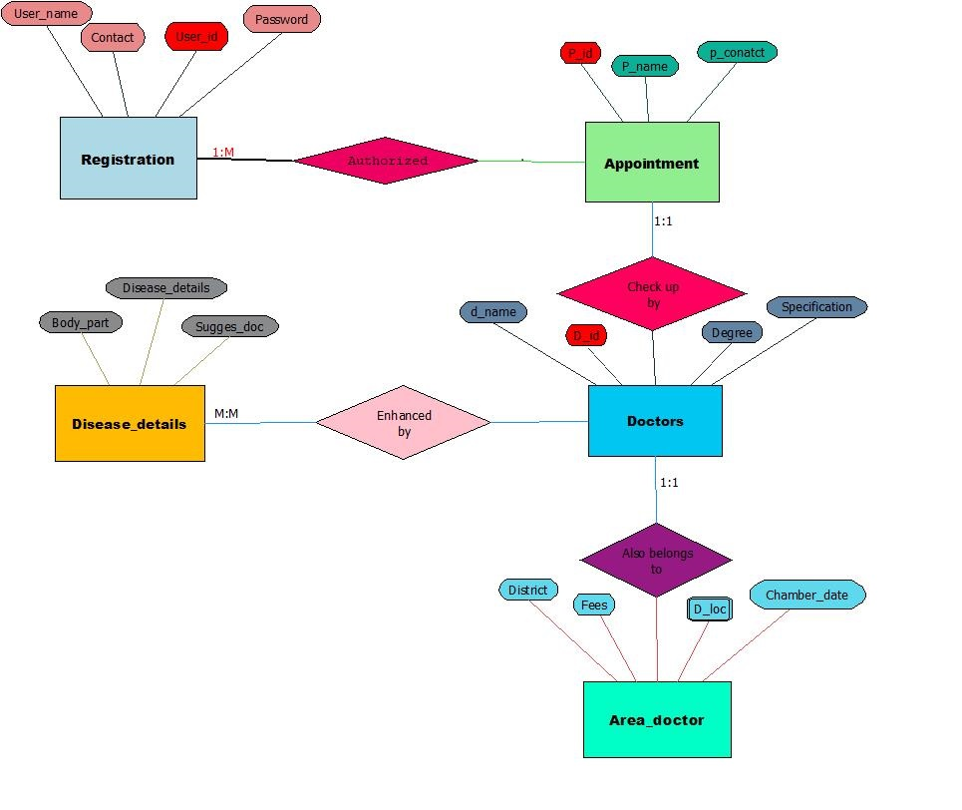

System Diagram

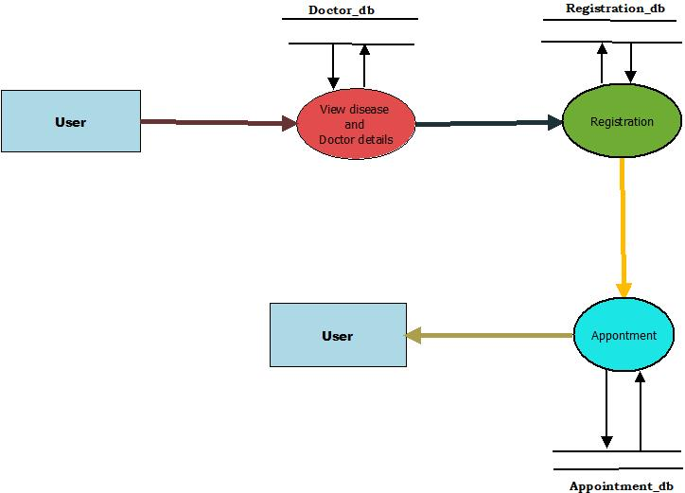

Coding

CODING OF APPOINTMENT
Imports System
Imports System.Data
Imports System.Data.SqlClient
Partial Class Appointment2
Inherits System.Web.UI.Page
Dim con As SqlConnection
Dim com As SqlCommand
Dim da As SqlDataAdapter
Dim ds As DataSet
Dim pv As String
Protected Sub Page_Load(ByVal sender As Object, ByVal e As System.EventArgs) Handles Me.Load
TextBox_did.Text = Session("doc1")
TextBox_dname.Text = Session("doc2")
TextBox_dcontact.Text = Session("doc3")
TextBox_dexperience.Text = Session("doc4")
TextBox_dspecification.Text = Session("doc5")
TextBox_dspecialization.Text = Session("doc6")
TextBox_pid.Text = Session("userid")
Dim x As String
x = Session("doc1")
con = New SqlConnection("Data Source=.\SQLEXPRESS;AttachDbFilename=E:\Visual Studio\Web Project\Area Based Doctor\App_Data\Database.mdf;Integrated Security=True;User Instance=True")
con.Open()
da = New SqlDataAdapter("select d_loc,area_name,chamber_day,chamber_time,fees from Area_doctor where d_id='" & x.ToString & "'", con)
ds = New DataSet
da.Fill(ds, "appoint")
TextBox_dloc.Text = ds.Tables("appoint").Rows(0)(0).ToString
TextBox_daddr.Text = ds.Tables("appoint").Rows(0)(1).ToString
TextBox_dchamberday.Text = ds.Tables("appoint").Rows(0)(2).ToString
TextBox_dchambertime.Text = ds.Tables("appoint").Rows(0)(3).ToString
TextBox_dfees.Text = ds.Tables("appoint").Rows(0)(4).ToString

End Sub

Protected Sub Button_cancel_Click(ByVal sender As Object, ByVal e As System.EventArgs) Handles Button_cancel.Click
TextBox_did.Text = ""
TextBox_dname.Text = ""
TextBox_dcontact.Text = ""
TextBox_dexperience.Text = ""
TextBox_dloc.Text = ""
TextBox_daddr.Text = ""
TextBox_dspecification.Text = ""
TextBox_dspecialization.Text = ""
TextBox_dchamberday.Text = ""
TextBox_dchambertime.Text = ""
TextBox_pregname.Text = ""
TextBox_pname.Text = ""
TextBox_paddress.Text = ""
TextBox_pcontact.Text = ""
TextBox_pid.Text = ""
TextBox_diseasesname.Text = ""
TextBox_appointdate.Text = ""
TextBox_appointtime.Text = ""
TextBox_dfees.Text = ""
RadioButton_yes.Checked = False
RadioButton_no.Checked = False
Response.Redirect("Home2.aspx")
End Sub

Protected Sub Button_reset_Click(ByVal sender As Object, ByVal e As System.EventArgs) Handles Button_reset.Click

TextBox_pregname.Text = ""
TextBox_pname.Text = ""
TextBox_paddress.Text = ""
TextBox_pcontact.Text = ""
TextBox_pid.Text = ""
TextBox_diseasesname.Text = ""
TextBox_appointdate.Text = ""
TextBox_appointtime.Text = ""
RadioButton_yes.Checked = False
RadioButton_no.Checked = False
End Sub

Protected Sub Button_submit_Click(ByVal sender As Object, ByVal e As System.EventArgs) Handles Button_submit.Click
con = New SqlConnection("Data Source=.\SQLEXPRESS;AttachDbFilename=E:\Visual Studio\Web Project\Area Based Doctor\App_Data\Database.mdf;Integrated Security=True;User Instance=True")
con.Open()
If RadioButton_yes.Checked = True Then
pv = "Yes"
Else
pv = "No"
End If
com = New SqlCommand("insert into Appointment(d_id,d_name,d_contact,d_exp,d_loc,d_address,d_specification,d_specialization,chamber_day,chamber_time,fees,p_regname,p_name,p_address,p_contact,p_id,p_diseases,pre_visit,appoint_date,appoint_time,appoint_done) values('" & TextBox_did.Text & "','" & TextBox_dname.Text & "','" & TextBox_dcontact.Text & "','" & TextBox_dexperience.Text & "','" & TextBox_dloc.Text & "','" & TextBox_daddr.Text & "','" & TextBox_dspecification.Text & "','" & TextBox_dspecialization.Text & "','" & TextBox_dchamberday.Text & "','" & TextBox_dchambertime.Text & "','" & TextBox_dfees.Text & "','" & TextBox_pregname.Text & "','" & TextBox_pname.Text & "','" & TextBox_paddress.Text & "','" & TextBox_pcontact.Text & "','" & TextBox_pid.Text & "','" & TextBox_diseasesname.Text & "','" & pv & "','" & TextBox_appointdate.Text & "','" & TextBox_appointtime.Text & "','NO')", con)
com.ExecuteNonQuery()
MsgBox("Appointment Successful.....", MsgBoxStyle.Information, "Appointment")
con.Close()

End Sub
End Class

OUTPUT

HOME
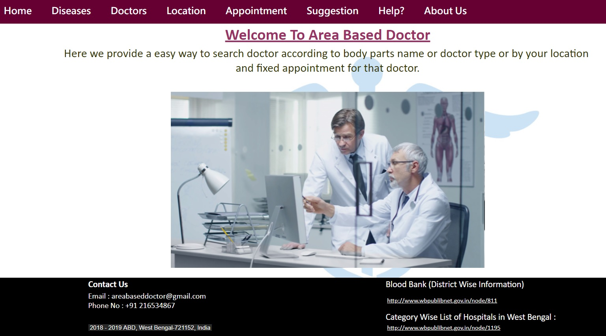

USER RESGIATRATION
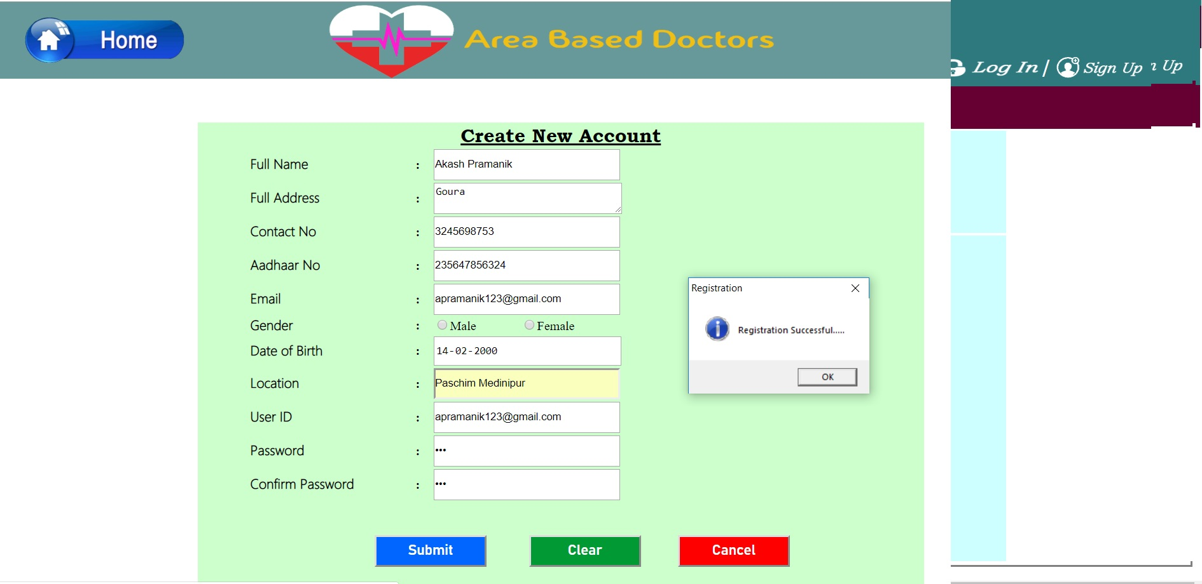
LOG IN

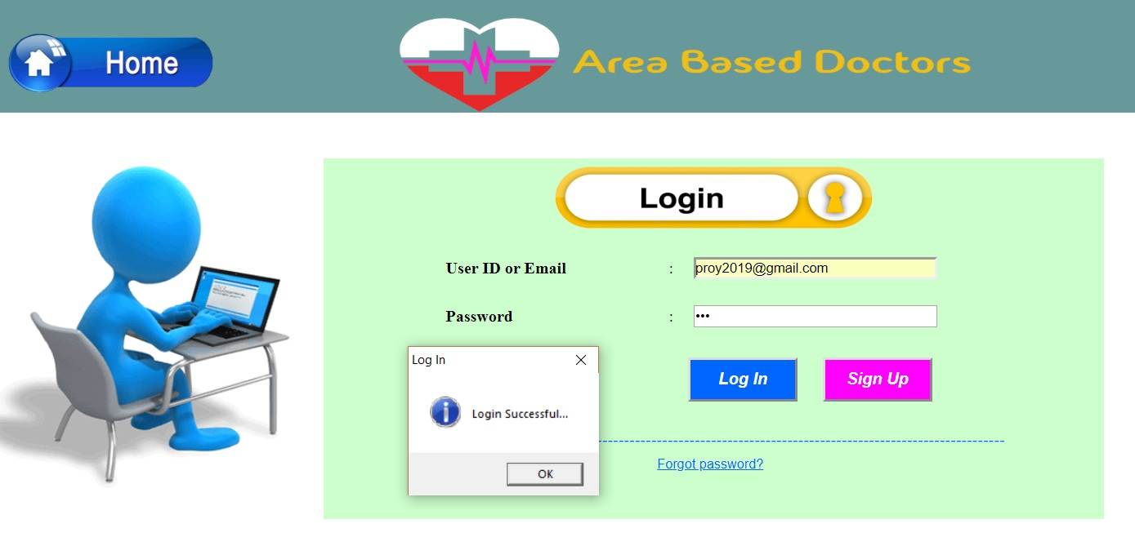
DISEASES

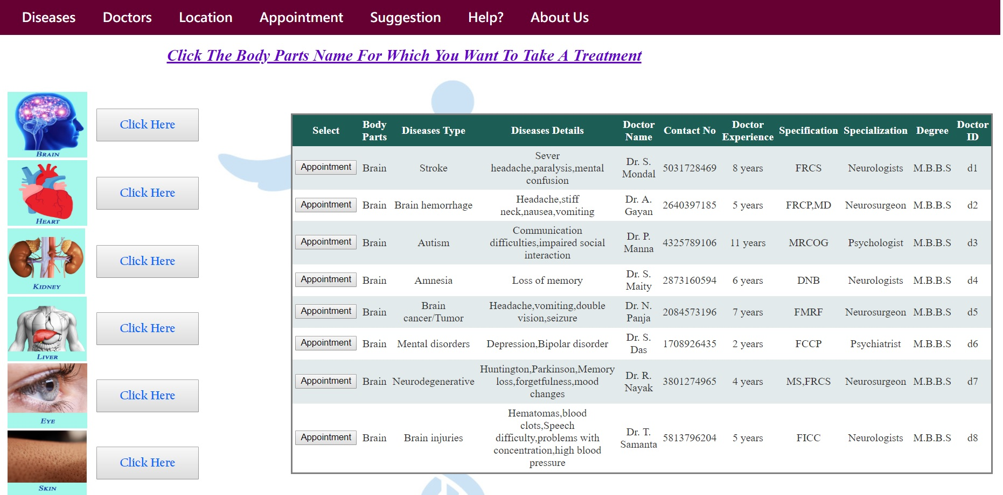
DOCTOR

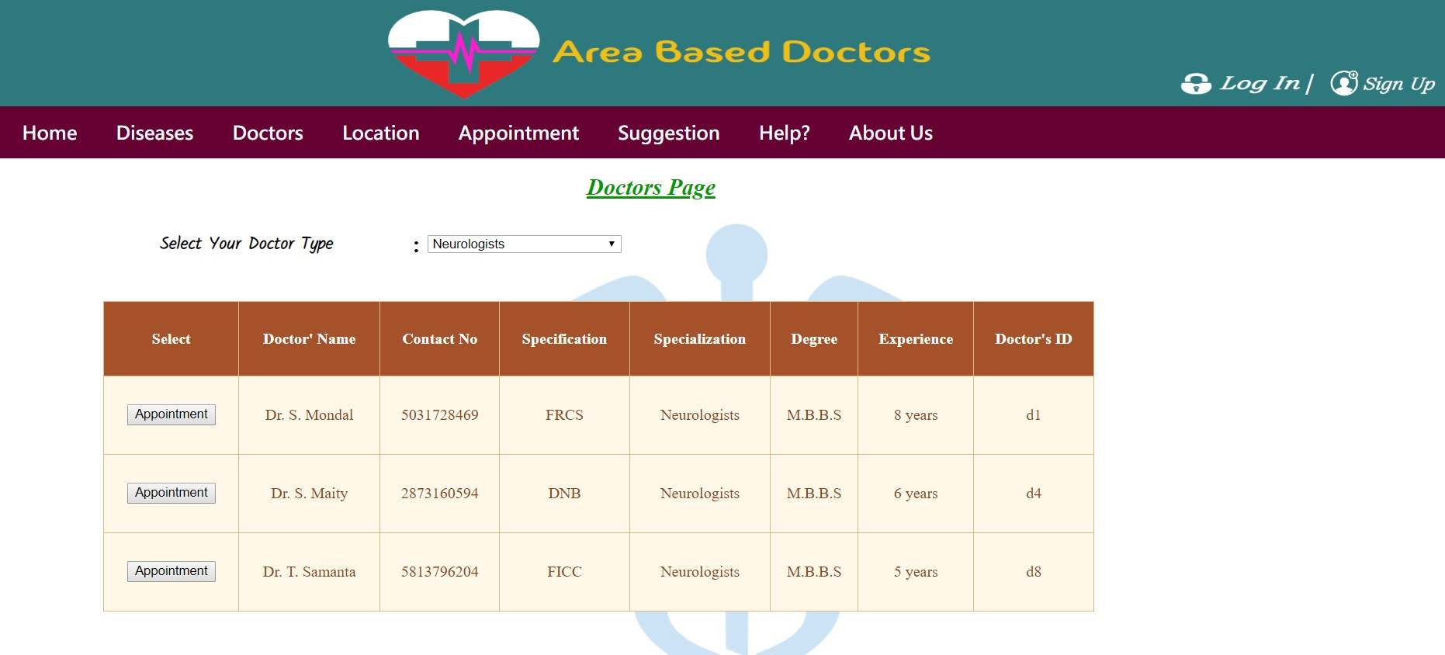
LOCATION

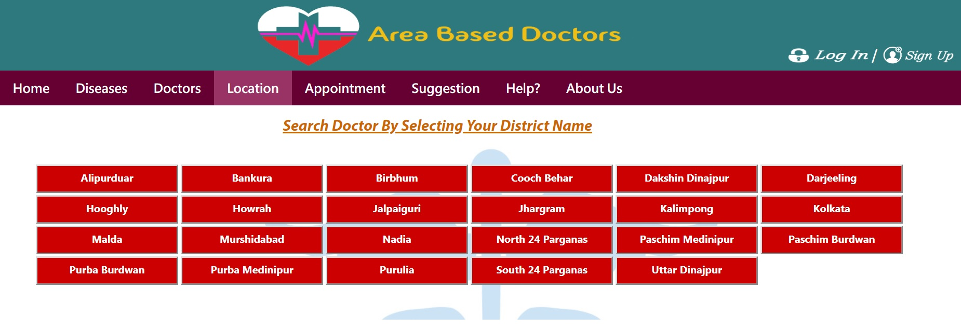
DOCTOR’S DETAILS OF PASCHIM MEDINIPUR

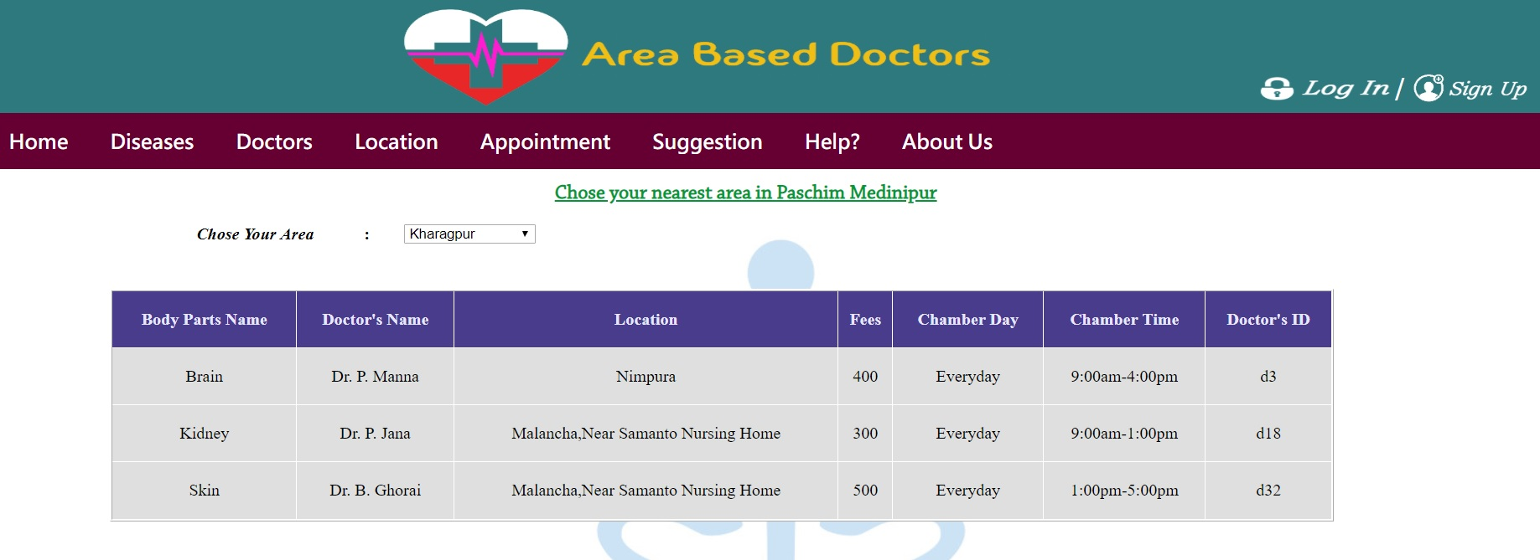
APPOINTMENT

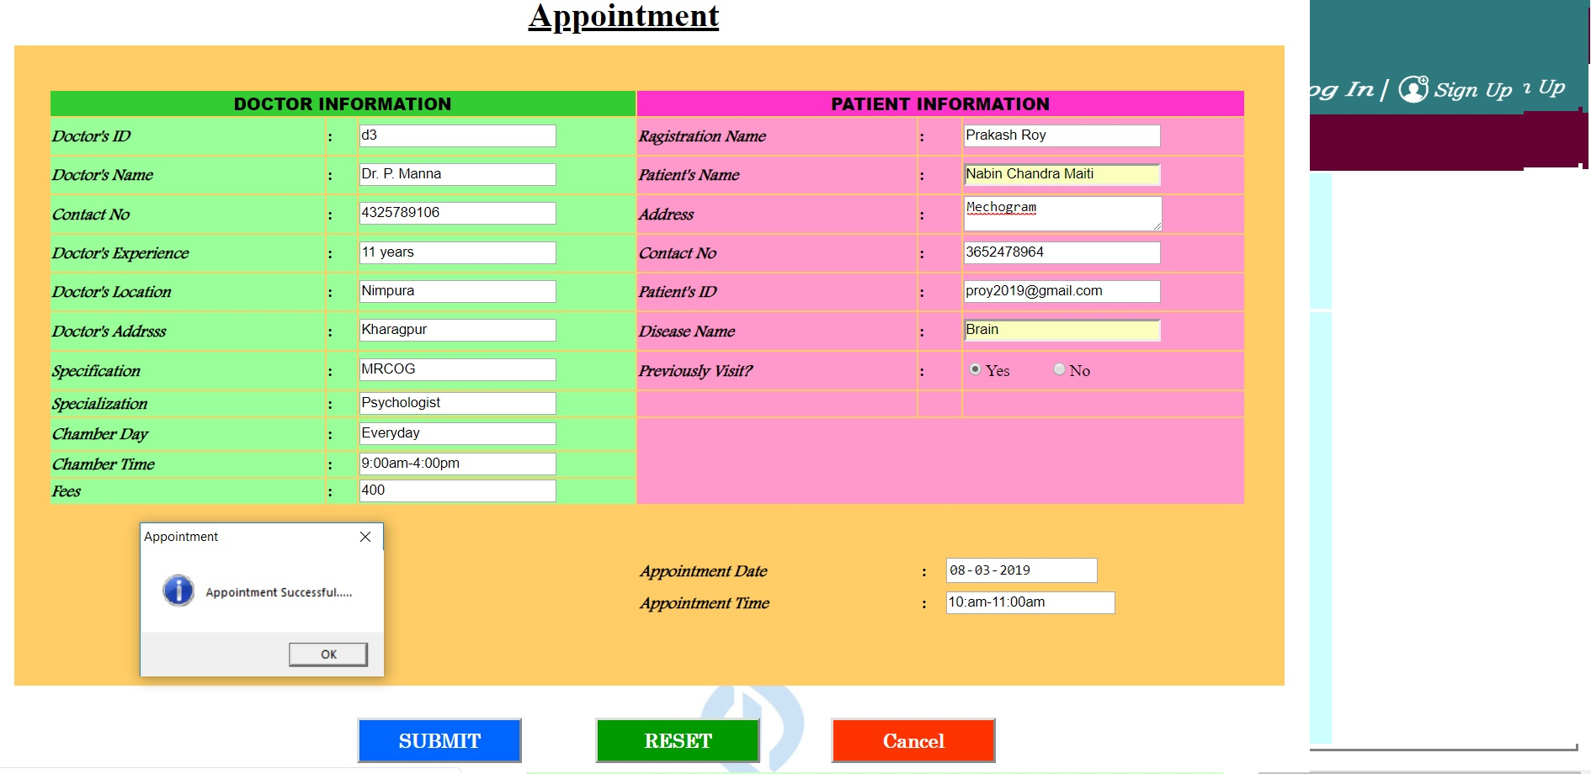
APPOINTMENT RECEIPT
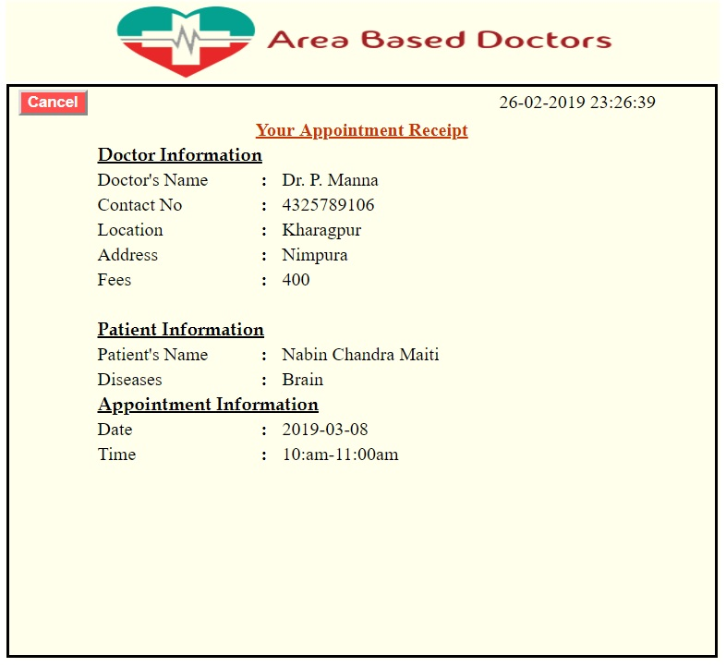
SUGGESTION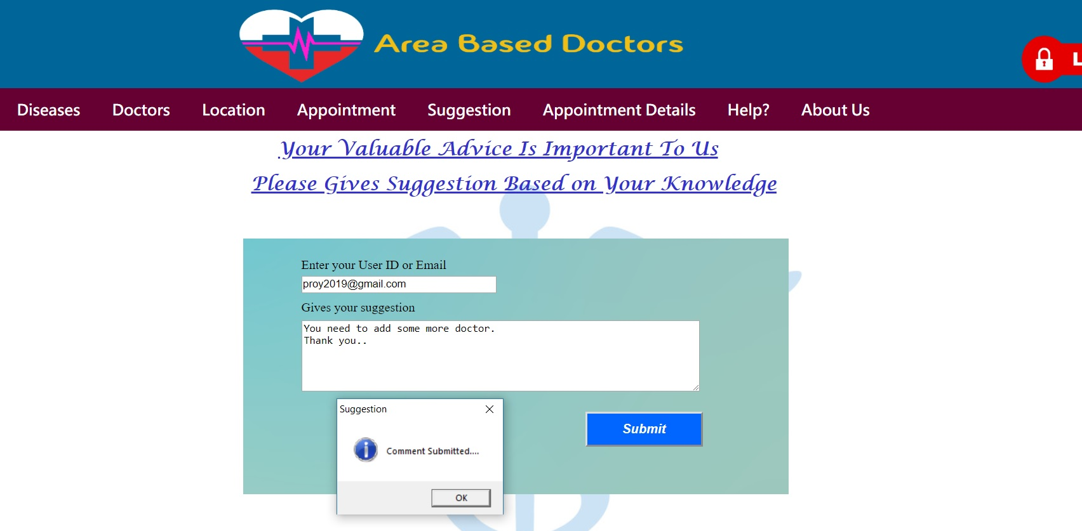
HELP

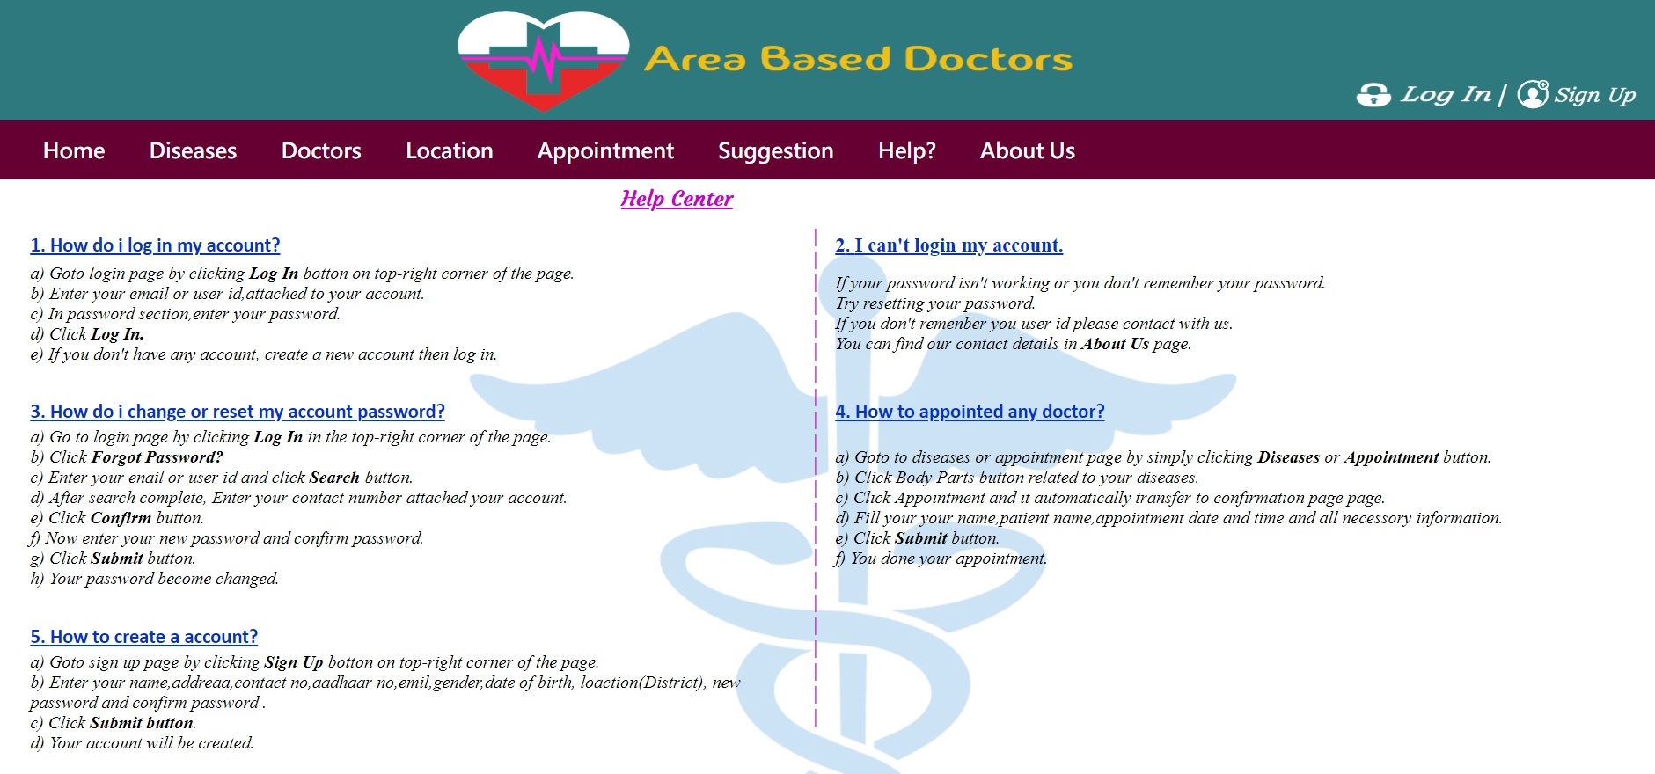
ABOUT US

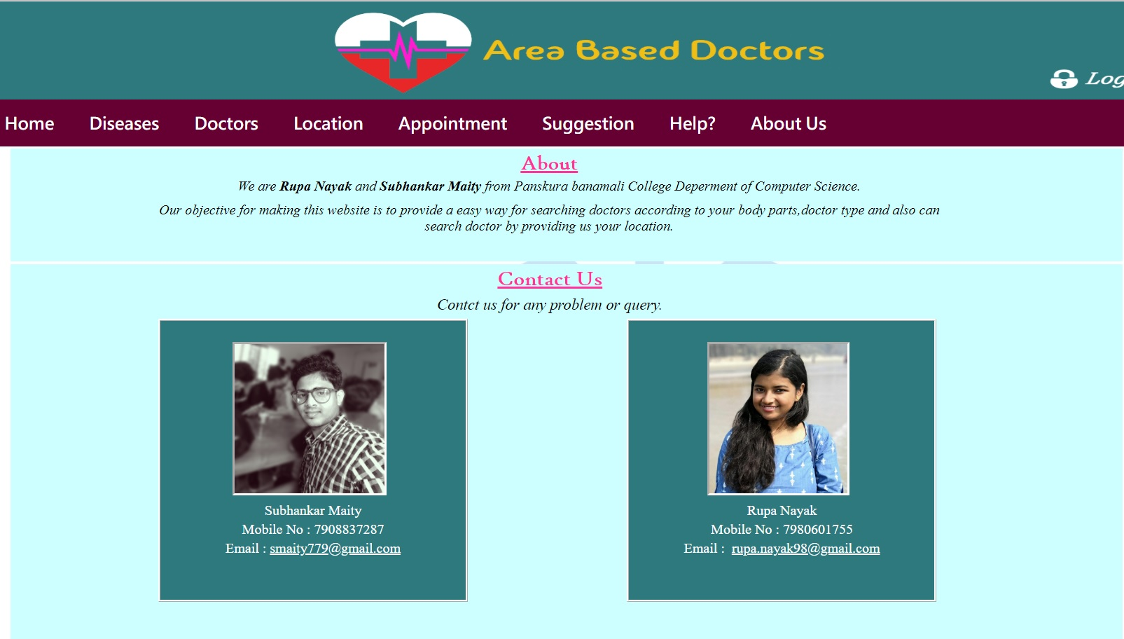
FORGOT PASSWORD
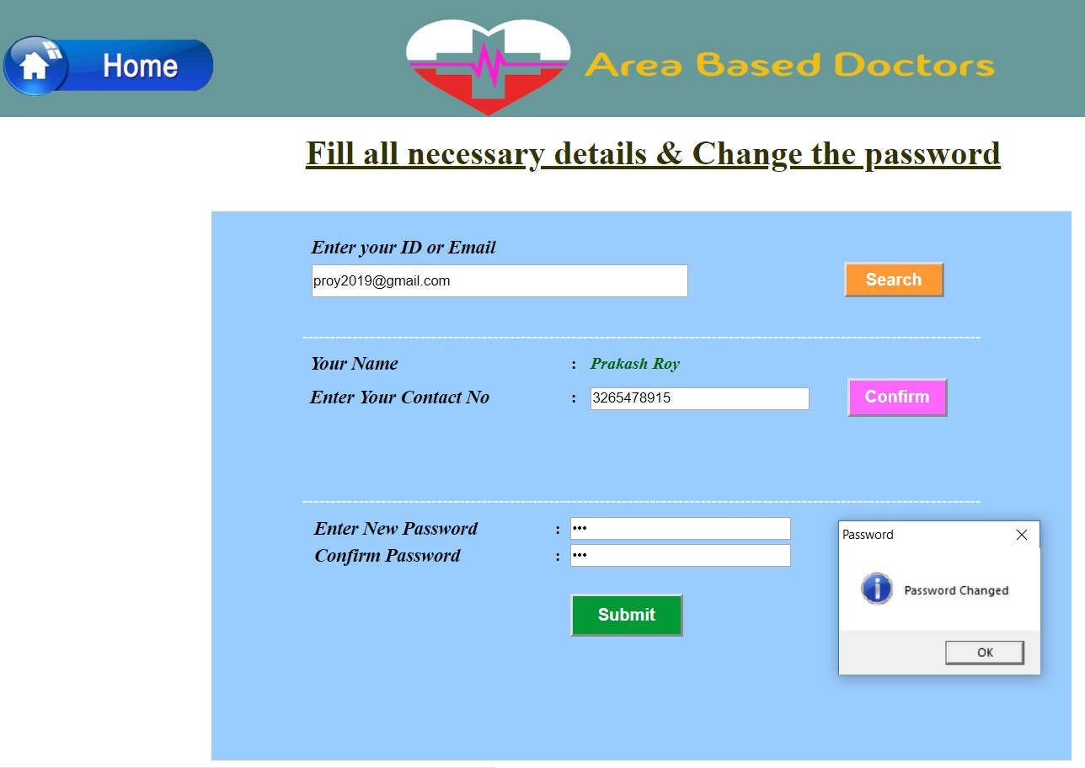

ADMIN LOGIN
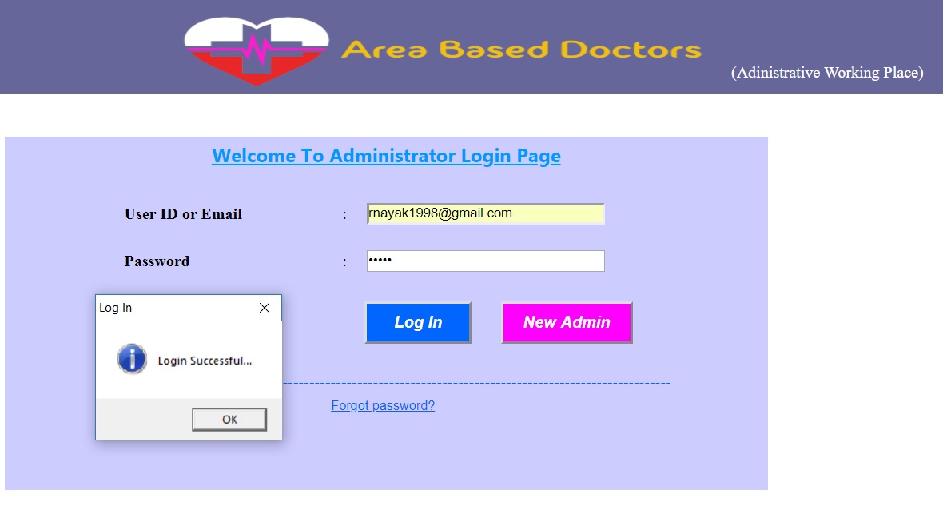
ADMIN HOME

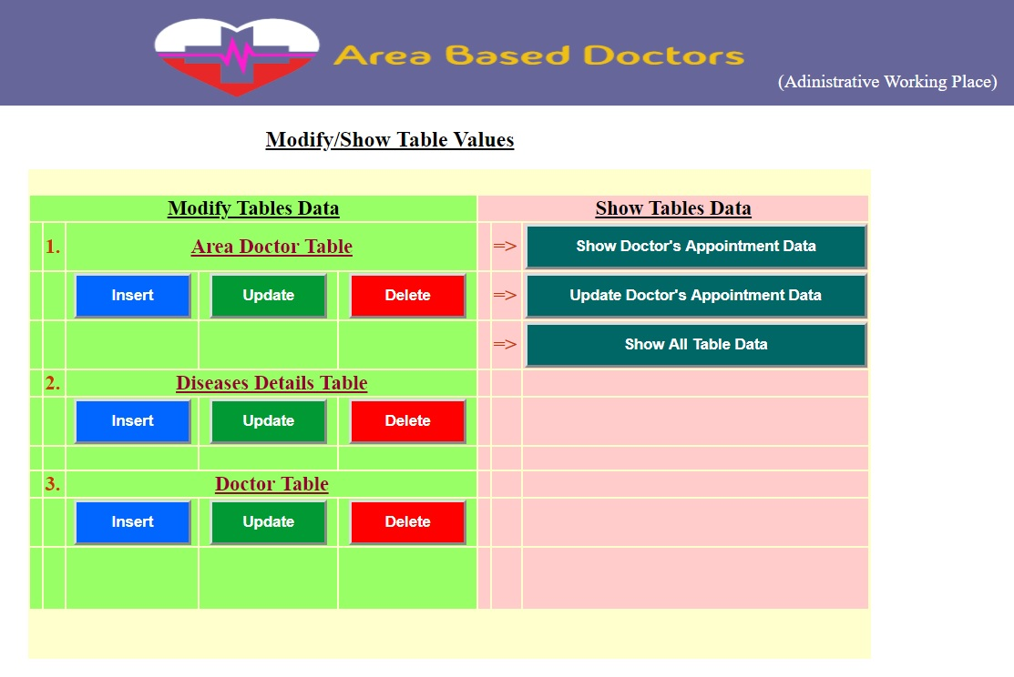
SHOW TABLE DATA
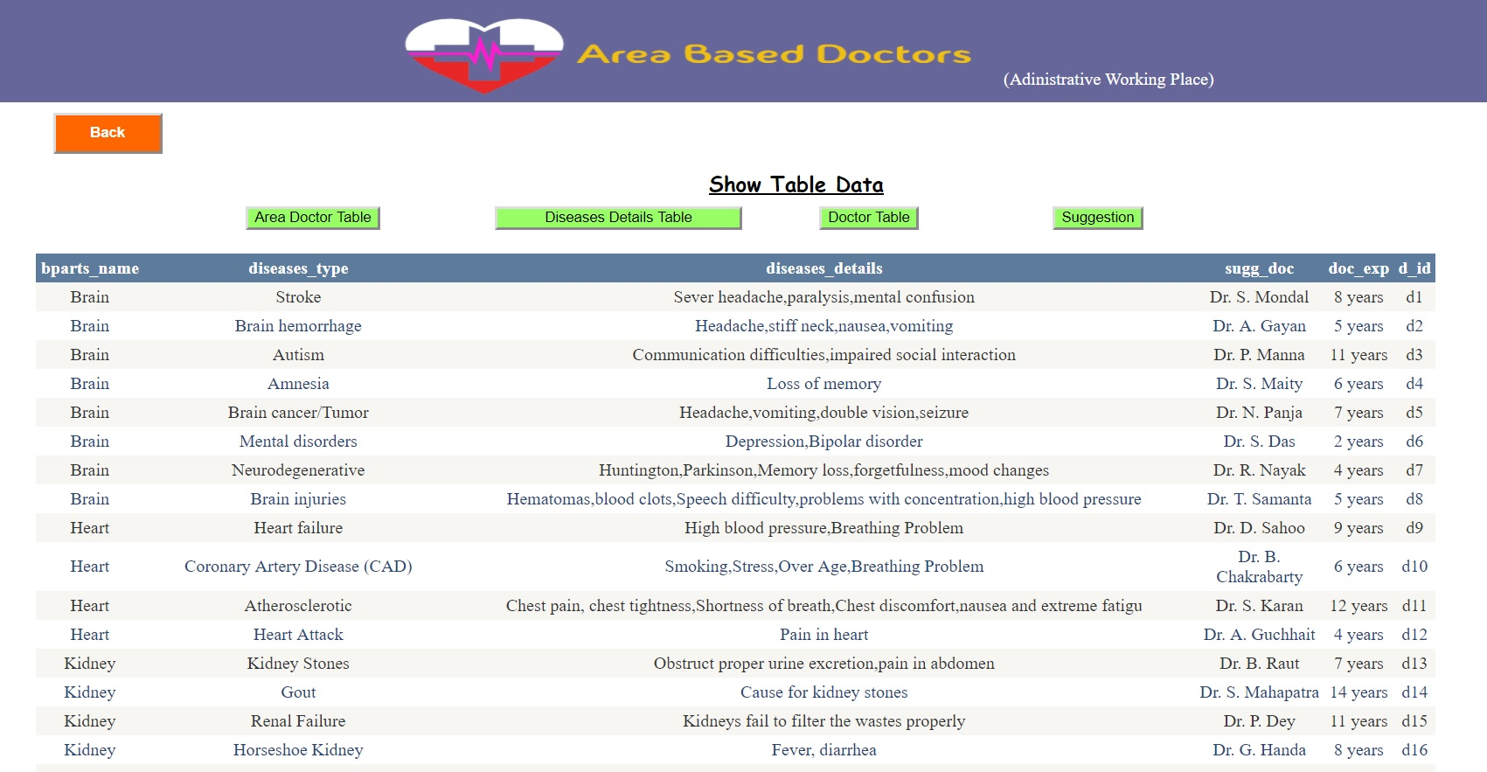
UPDATE TABLE DATA

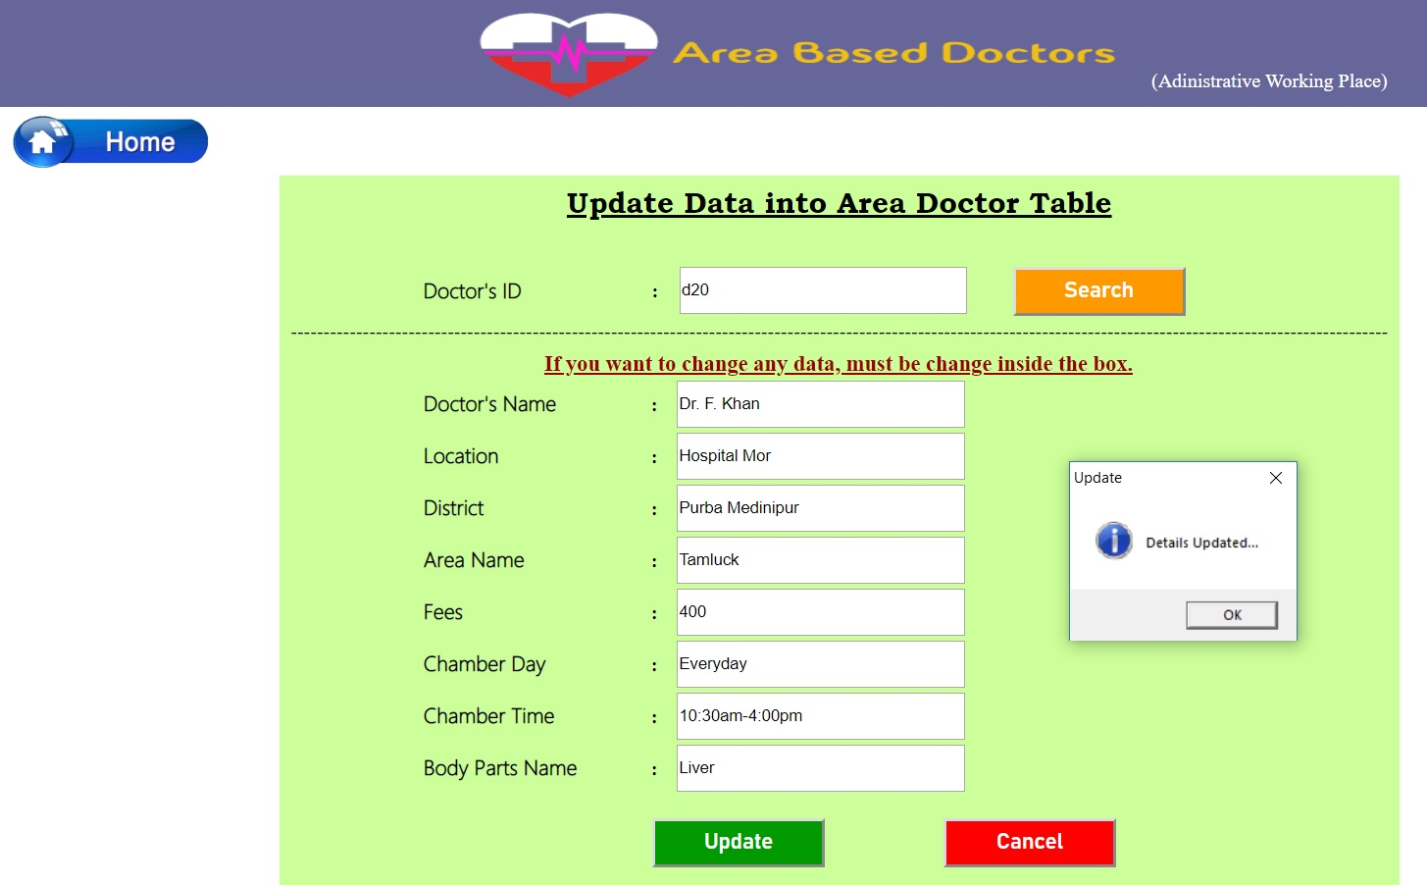
SHOW ALL APPOINTMENT

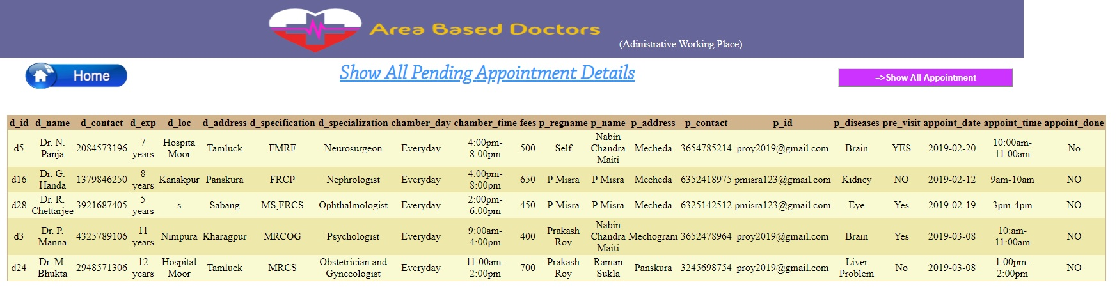

TESTING:-

Testing is a process of executing a program with the indent of finding an error. Testing is a crucial element of software quality assurance and presents ultimate review of specification, design and coding.
System Testing is an important phase. Testing represents an interesting anomaly for the software. Thus a series of testing are performed for the proposed system before the system is ready for user acceptance testing.
A good test case is one that has a high probability of finding an as undiscovered error. A successful test is one that uncovers an as undiscovered error.
- Testing Objectives:
- Testing is a process of executing a program with the intent of finding an error
- A good test case is one that has a probability of finding an as yet undiscovered error
- A successful test is one that uncovers an undiscovered error
- Testing Principles:
- All tests should be traceable to end user requirements
- Tests should be planned long before testing begins
- Testing should begin on a small scale and progress towards testing in large
- Exhaustive testing is not possible
- To be most effective testing should be conducted by a independent third party

The primary objective for test case design is to derive a set of tests that has the highest livelihood for uncovering defects in software. To accomplish this objective two different categories of test case design techniques are used. They are
- White box testing.
- Black box testing.

White-box testing:
White box testing focus on the program control structure. Test cases are derived to ensure that all statements in the program have been executed at least once during testing and that all logical conditions have been executed.

Block-box testing:
Black box testing is designed to validate functional requirements without regard to the internal workings of a program. Black box testing mainly focuses on the information domain of the software, deriving test cases by partitioning input and output in a manner that provides through test coverage. Incorrect and missing functions, interface errors, errors in data structures, error in functional logic are the errors falling in this category.
Testing strategies:
A strategy for software testing must accommodate low-level tests that are necessary to verify that all small source code segment has been correctly implemented as well as high-level tests that validate major system functions against customer requirements.
Testing fundamentals:
Testing is a process of executing program with the intent of finding error. A good test case is one that has high probability of finding an undiscovered error. If testing is conducted successfully it uncovers the errors in the software. Testing cannot show the absence of defects, it can only show that software defects present.

Conclusion

This project will helps the patients to search their doctor on based of location and take appointment accordingly. Due to short time we are not able to implement more of this project in future we will work on it.

BIBLIOGRAPHY

The following books are referred during the analysis and execution phase of the project

MICROSOFT .NET WITH vb
Microsoft .net series

VB.NET WITH 2010
Apress Publications

VB.NET 2.0 PROFESSIONAL
Wrox Publishers

PROGARMMING MICROSOFT vb.NET APPLICATION
Wrox Professional Guide

WEBSITES:
www.google.com
www.youtube.com
www.microsoft.com
www.wikipedia.com

Visual Basic.Net:The Complete Referance(Jeffrey R.Shapiro)

Visual Basic.Net:Black Book(Steven Holzer)

REFERANCE

www.google.com
www.youtube.com
www.wikipedia.com

Visual Basic.Net:The Complete Referance(Jeffrey R.Shapiro)

Visual Basic.Net:Black Book(Steven Holzer)

